Remote Command Execution using UDP

**Ex No:** 9

**Date:** 15/10/2020

**Name:** Siddhant Thakur

**Reg No.:** RA1811027010004

**Aim**: To perform Remote Command Execution using UDP with the help of socket programming.

**Code**:

**Server Side :-**

import socket

import os

s = socket.socket(socket.AF_INET, socket.SOCK_DGRAM)

s.bind(("127.0.0.1", 8000))

print(s.recvfrom(1024)[0].decode())

while True:

x = s.recvfrom(1024)

if (x[0].decode() == "stop"):

break

ops = os.popen(x[0].decode())

op = ops.read()

print(op)

s.sendto(op.encode(), x[1])

**Client Side :-**

import socket

import os

cl = socket.socket(socket.AF_INET, socket.SOCK_DGRAM)

addr = ("127.0.0.1", 8000)

cl.sendto("Connection established".encode(), addr)

while True:

x = input("Enter the command: ")

cl.sendto(x.encode(), addr)

y = cl.recvfrom(1024)

print("Server's output : ", y[0].decode())

**Output**

Left Terminal is server side

Right Terminal is client side.

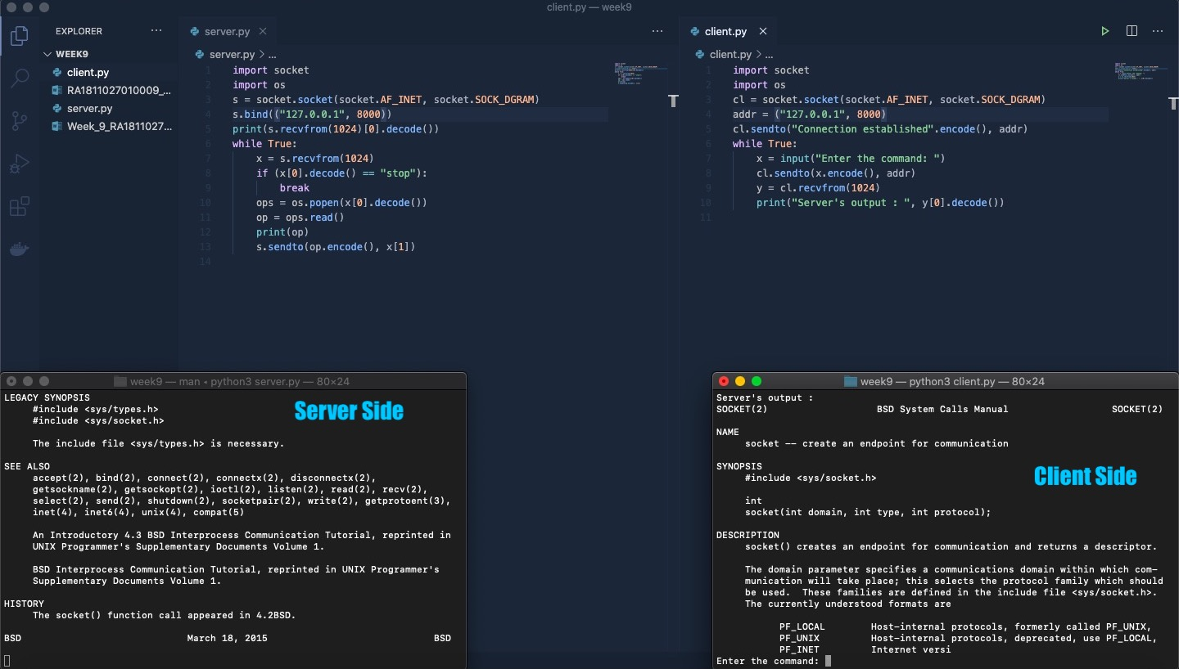

**Result**: Remote commands were successfully executed using UDP.